**Visual identity book of**

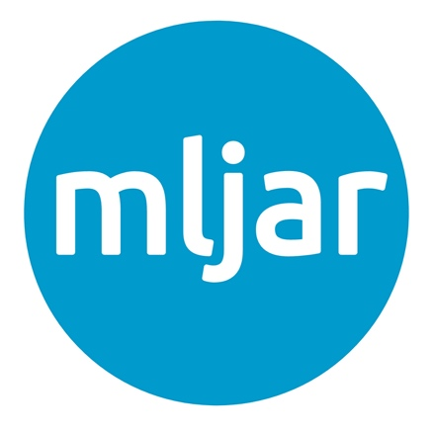

1. **Colors**

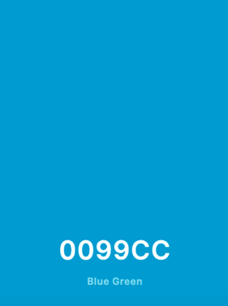

Brand logo color:

#0099CC

Secondary palette colors:

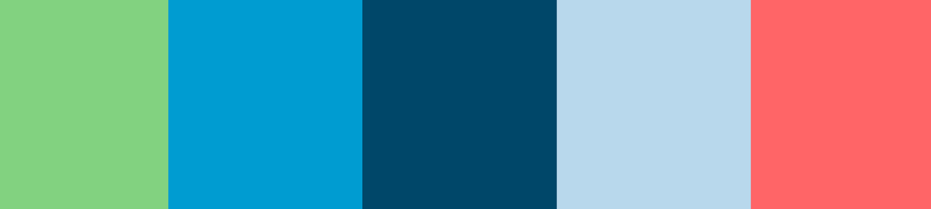

#97D088 #0099CC #004666 #BFD7EA #EF6F6C

Pistachio Blue Green Indigo Dye Beau Blue Light Coral

rgb (151,208,136) rgb (0,153,204) rgb (0,70,102) rgb (191,215, 234) rgb (239,111,108)

CMYK (27%,0%,35%,18%) CMYK (100%,25%,0%,20%) CMYK (100%, 31%, 0%, 60%) CMYK (18%,8%,0%,8%) CMYK (0%,54%,55%,6%)

### Typography

**Logo: font Ubuntu**

**mljar**

**Font** on the website: **Ubunt**

Aa Bb Cc Dd Ee Ff Gg Hh Ii Jj Kk Ll Mm Nn Oo Pp Qq Rr Ss Tt Uu Ww Xx Yy Zz

1234567890!@#$%^&*()<><>?|\,./

1. **Types of logo:**

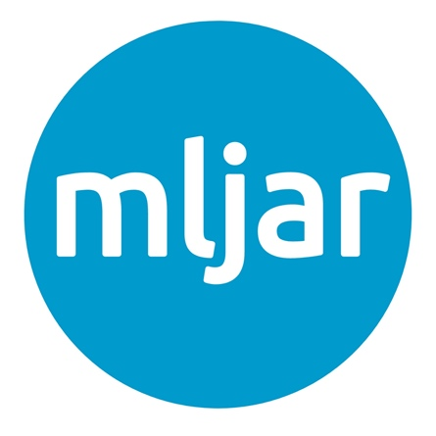

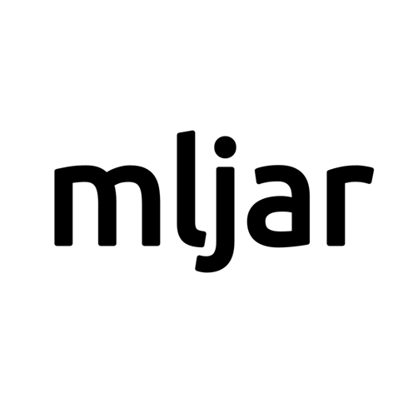

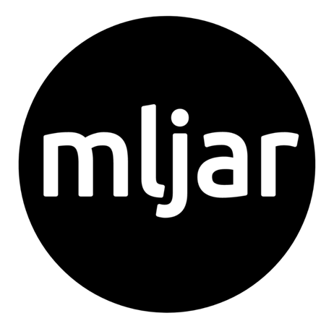

1. **Icons**

**Icons from website** [**https://uxwing.com/**](https://uxwing.com/) **in one of colors from above.**

    

1. **Favicon**



1. **Pictures**

**Pictures from website undraw.co (color #0099CC)**

**Examples:**

